

GRADUATION PROJECT DOCUMENTATION
MORSHEDY GROUP PORTFOLIO

Contents
Business Problem Statement 4
Project Mission & Analytical Objectives 5
Ingestion & Data Transformation 6
Data Dictionary 6
Dimensional Modeling Stage 13
Mapping Sheet 17
DAX Business Logic & Measures 21
Report Architecture & UI/UX Design 29
Insights and Recommendations 33

In this documentation, we will include all analytical stages of this project including:

- Business Problem Statement
- Project Mission & Analytical Objectives
- Ingestion & Data Transformation
- DAX Business Logic & Measures
- Report Architecture & UI/UX Design
- Insights & Recommendations

Business Problem Statement
The real estate company sells units through installment plans. However, the collection data is stored across multiple project worksheets, making it difficult to monitor the overall collection performance.
The core business challenges are:
- Data is distributed across 8 project worksheets.
- Installment information is stored in multiple columns and different business states.
- Management needs to identify paid, due, and not-yet-due installments.
- It is difficult to monitor collected and outstanding amounts in one place.
- Management needs visibility into bank exposure and project progress.
The company needs a unified solution that provides a clear view of sales, collections, outstanding balances, and project performance.

Project Mission & Analytical Objectives
Project Mission
- To build a unified Power BI dashboard that helps management monitor sales performance, installment collections, outstanding balances, bank exposure, and project progress across all real estate projects.
Analytical Objectives
- Analyze sales performance across projects.
- Measure the number and percentage of sold units.
- Track issued and collected installments.
- Calculate collected and outstanding amounts.
- Measure collection rate and outstanding percentage.
- Monitor project completion percentage.
- Separate Cash and Bank-financed sales.
- Analyze outstanding balances by bank.
- Compare collection performance between old and new periods.

Ingestion & Data Transformation
- The source data contains 8 project worksheets with a standard structure of 21 columns.
- The main data preparation steps were:
- Explore and understand the structure of all project worksheets.

Data Dictionary
Row Name | Row name after cleaning | Meaning
اسم العميل | Customer Name | Customer record; control rows are not customers
رقم الهوية | National ID | Customer identification value
رقم الوحدة | Unit Number | Business unit number.
كود الوحدة | Unit Code | Additional unit reference.
سعر الوحدة | Unit Price | Selling price of the unit.
نسبة الانجاز من الاستشاري الهندسي | Consultant Progress Percentage | % completion value received from  engineering.
جدول الدفعات | Payment Schedule | Installment percentage plan.
الدفعة + رقم | Installment Number | Seven cells containing installment state  and/or value.
مجموع الدفعات المستحقة | Total Outstanding Payments | Total amount currently due for the  customer.
مجموع الدفعات المدفوعة | Total Payments Made | Total amount already collected.
البنك | Bank | Cash or financing bank.
تاريخ عقد البيع | Date of Contract | Date of the sales contract.
POC | Project Completion % | Percentage of completion used in the  report KPI.
رقم عقد البيع | Sales Contract Number | Contract reference.
Date | Date | Reporting date used in date analysis.

- Remove the 3 control rows from customer-level data.
At the end of every project sheet, three special rows summarize the installment columns.
Use them as control totals and exclude them from customer counts.
Summary Total: Total issued invoice amount for each installment.
Paid Installments: Total collected amount for each installment.
Remaining Installments: Total outstanding amount for each installment.
Required reconciliation
For every installment: Summary Total = Paid Installments + Remaining Installments.

- Standardize data types such as dates, currencies, and contract numbers like:
- Change datatype of (رقم الهوية) from int to string
- Change datatype of (نسبة الانجاز من الاستشاري الهندسي) from decimal number to percentage
- Change datatype of (POC) from decimal number to percentage
- We isolate the control rows to another file
- We did unpivot for the installments into a vertical tabular format (Customer ID, Unit Number, Installment Number, Raw Value).
- We create conditional classification rules for each installment row: PAID: Issued and collected. DUE - NOT PAID: Issued and outstanding. NOT DUE: Not yet payable (excluded from issued invoice counts) using this formula:
if Text.Contains(Text.From([Raw Value]), "تم السداد") then
"PAID"
else if Text.Contains(Text.From([Raw Value]), "غير مستحقة") then
"NOT DUE"
else
"DUE – NOT PAID"

- We have changed the columns’ names from Arabic into English.

- Standardize bank names, manage missing values, and identify Cash sales.
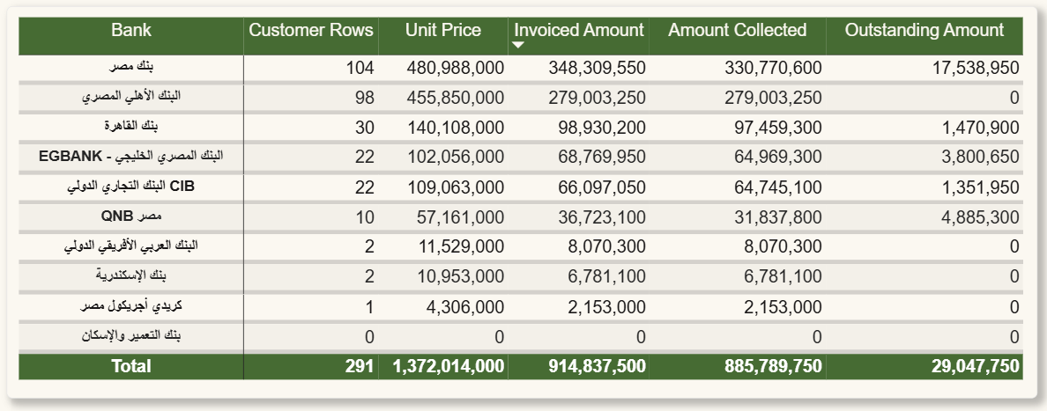

- Bank names were standardized to ensure that the same bank was represented by one consistent name.

- Different formats and duplicate spellings were corrected. Blank bank values were reviewed and managed based on the available sales information, while the value “Cash” was kept as a separate category for non-bank-financed sales.

- Unpivot Installment 1 to Installment 7 into a vertical structure.

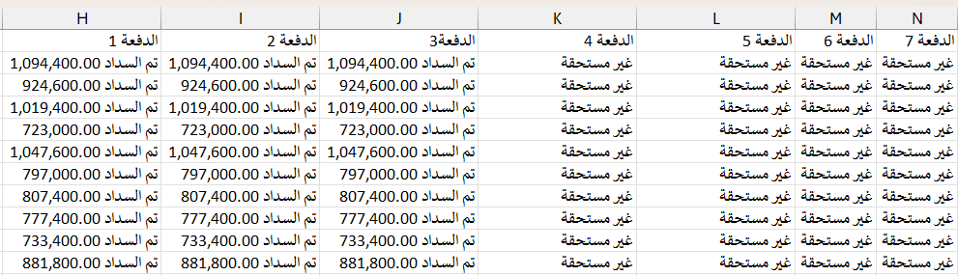

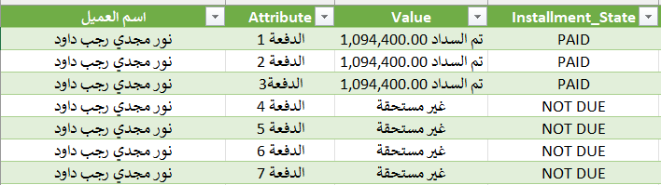

- Unpivot Installments: Convert wide installment columns (Installment 1 to 7) into a vertical tabular format (Customer ID, Unit Number, Installment Number, Raw Value).

- Create an installment classification based on three business states:

PAID / DUE - NOT PAID / NOT DUE

- PAID: Issued and collected.
- DUE - NOT PAID: Issued and outstanding.
- NOT DUE: Not yet payable (excluded from issued invoice counts).
if Text.Contains(Text.From([Raw Value]), "تم السداد") then
"PAID"
else if Text.Contains(Text.From([Raw Value]), "غير مستحقة") then
"NOT DUE"
else
"DUE – NOT PAID"

As a result of these steps, we have prepared clean data for the dimensional model and Power BI analysis.

Dimensional Modeling Stage
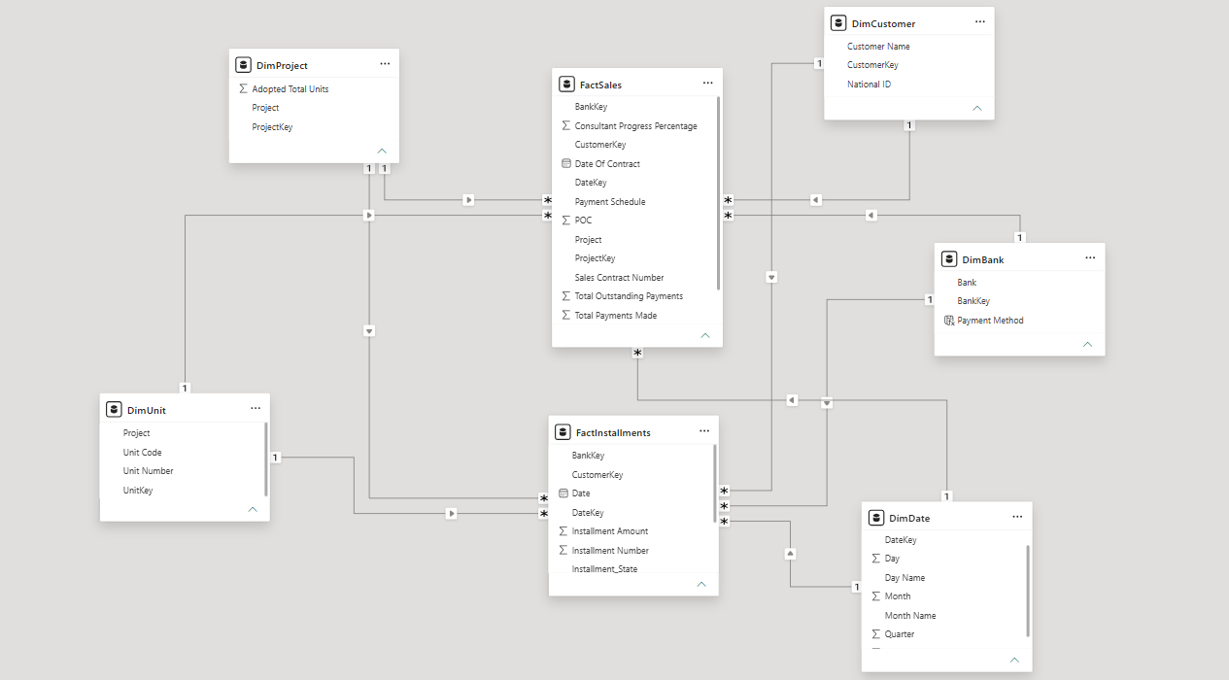

We have 2 fact tables and 5 dimension tables (Galaxy Schema):
- Dim Customer
- Dim Bank
- Dim Date
- Dim Unit
- Dim Project
- Fact Sales
- Fact Installments

Dim Customer:
- CustomerKey (Whole Number)
- National ID (Text)
- Customer Name (Text)
Dim Bank:
- Bank (Text)
- Bankey (Whole Number)
- Payment Method (Text)

Dim Date:
- Date (Date)
- Year (Whole Number)
- Month (Whole Number)
- Month Name (Text)
- Quarter (Whole Number)
- Day (Whole Number)
- Day Name (Text)
- DateKey (Whole Number)

Dim Unit:
- UnitKey (Whole Number)
- Unit Number (Text)
- Unit Code (Text)
- Project (Text)

Dim Project:
- Project (Text)
- ProjectKey (Whole Number)
- Adopted Total Units (Whole Number)

In this model, we model two fact tables, each of them has different grain:
- FactSales

Each row describes a unit sold to a specific customer in a specific project with details about this unit

FactSales:
- Unit Price (Whole Number)
- Consultant Progress Percentage (Percentage)
- Payment Schedule (Text)
- Total Outstanding Payments (Whole Number)
- Total Payments Made (Whole Number)
- Date of Contract (Date)
- POC (Percentage)
- Sales Contract Number (Text)
- Project (Text)
- ProjectKey (Whole Number)
- CustomerKey (Whole Number)
- UnitKey (Whole Number)
- BankKey (Whole Number)
- DateKey (Whole Number)

- FactInstallments

Each row describes an installment paid by a specific customer for a specific project with details about this installment.

FactInstallments:
- Installment_State (Text)
- Sales Contract Number (Text)
- Project (Text)
- Installment Amount (Whole Number)
- Installment Number (Whole Number)
- ProjectKey (Whole Number)
- DateKey (Whole Number)
- CustomerKey (Whole Number)
- UnitKey (Whole Number)
- BankKey (Whole Number)
- Date (Date)

(CustomerKey/BankKey/DateKey/ProjectKey/UnitKey) all are surrogate keys
Surrogate Key: identifier attribute generated by system for each instance (row) help to distinguish between the row or the instance of the same entity.

All the relationships are:
- Cardinality: One to many
- Cross-filter direction: Single
- Status: Active

This picture describes all the relationships in this project.
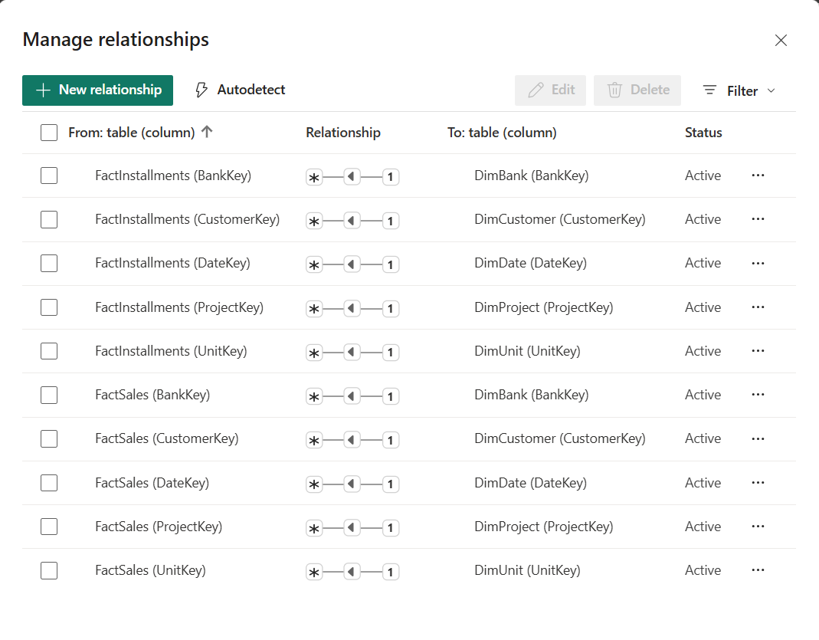

Mapping Sheet
In the next page, we have mapping sheet describing the relationship between source tables and the target tables

Source Table | Source Column | Target Table | Target Column | Transformation | Key Type | SCD
Data Source File | Generated | DimCustomer | CustomerKey | Generate Surrogate Key | PK | No
Data Source File | National ID | DimCustomer | National ID | Clean Text | - | No
Data Source File | Customer Name | DimCustomer | Customer Name | Clean Text | - | No
Data Source File | Generated | DimProject | ProjectKey | Generate Surrogate Key | PK | No
Data Source File | Project | DimProject | Project | Clean & Standardize Text | - | No
Advertised_Total_Units_File | Project | DimProject | Project | Merge / Lookup | - | No
Advertised_Total_Units_File | Adopted Total Units | DimProject | Adopted Total Units | Change Data Type | - | No
Data Source File | Generated | DimUnit | UnitKey | Generate Surrogate Key | PK | No
Data Source File | Project | DimUnit | Project | Clean Text | - | No
Data Source File | Unit Code | DimUnit | Unit Code | Clean Text | - | No
Data Source File | Unit Number | DimUnit | Unit Number | Clean Text | - | No
Data Source File | Generated | DimBank | BankKey | Generate Surrogate Key | PK | No
Data Source File | Bank | DimBank | Bank | Clean & Standardize Bank Name | - | No
Data Source File | Payment Method | DimBank | Payment Method | Derived from Bank | - | No
Data Source File | Date | DimDate | DateKey | Generate YYYYMMDD Key | PK | No
Data Source File | Date | DimDate | Date | Generate Date Range | - | No
Data Source File | Date | DimDate | Year | Extract Year | - | No
Data Source File | Date | DimDate | Quarter | Extract Quarter | - | No
Data Source File | Date | DimDate | Month | Extract Month Number | - | No
Data Source File | Date | DimDate | Month Name | Format Month Name | - | No
Data Source File | Date | DimDate | Day | Extract Day | - | No
Data Source File | Bank | FactSales | Bank | Clean Text | - | No
Data Source File | Generated | FactSales | BankKey | Lookup from DimBank | FK | No
Data Source File | Consultant Progress Percentage | FactSales | Consultant Progress Percentage | Change Data Type | - | No
Data Source File | Customer Name | FactSales | Customer Name | Clean Text | - | No
Data Source File | Generated | FactSales | CustomerKey | Lookup from DimCustomer | FK | No
Data Source File | Date | FactSales | Date | Convert to Date | - | No
Data Source File | Date | FactSales | DateKey | Convert Date to YYYYMMDD | FK | No
Data Source File | DateofContract | FactSales | DateofContract | Convert to Date | - | No
Data Source File | National ID | FactSales | National ID | Clean Text | - | No
Data Source File | Payment Schedule | FactSales | Payment Schedule | Clean Text | - | No
Data Source File | POC | FactSales | POC | Change Data Type | - | No
Data Source File | Project | FactSales | Project | Clean Text | - | No
Data Source File | Generated | FactSales | ProjectKey | Lookup from DimProject | FK | No
Data Source File | Sales Contract Number | FactSales | Sales Contract Number | Clean Text | - | No
Data Source File | Total Outstanding Payments | FactSales | Total Outstanding Payments | Change Data Type | - | No
Data Source File | Total Payments Made | FactSales | Total Payments Made | Change Data Type | - | No
Data Source File | Unit Code | FactSales | Unit Code | Clean Text | - | No
Data Source File | Unit Number | FactSales | Unit Number | Clean Text | - | No
Data Source File | Unit Price | FactSales | Unit Price | Change Data Type | - | No
Data Source File | Generated | FactSales | UnitKey | Lookup from DimUnit | FK | No
Data Source File | Generated | FactInstallments | CustomerKey | Lookup from DimCustomer | FK | No
Data Source File | Date | FactInstallments | Date | Convert to Date | - | No
Data Source File | Date | FactInstallments | DateKey | Convert Date to YYYYMMDD | FK | No
Data Source File | Installment Amount | FactInstallments | Installment Amount | Unpivot Installment Columns | - | No
Data Source File | Installment State | FactInstallments | Installment State | Standardize Values | - | No
Data Source File | Installment Number | FactInstallments | Installment Number | Extract Number from Installment Column | - | No
Data Source File | Project | FactInstallments | Project | Clean Text | - | No
Data Source File | Generated | FactInstallments | ProjectKey | Lookup from DimProject | FK | No
Data Source File | Sales Contract Number | FactInstallments | Sales Contract Number | Clean Text | - | No
Data Source File | Generated | FactInstallments | UnitKey | Lookup from DimUnit | FK | No
Data Source File | Generated | FactInstallments | BankKey | Lookup from DimBank | FK | No

Date Selector
A separate Date Selector table was created to allow users to select a start and end date for the collection analysis.
It was kept separate from the main Dim Date table because the selected dates are used as parameters in the old and new collection measures, rather than as direct filters on the fact tables.
- Old: Transactions before the selected start date.
- New: Transactions from the selected start date to the selected end date.
This approach allows the report to compare old and new collections and outstanding amounts while keeping the historical data available for calculations.
The Dim Date table remains connected to the fact tables and is used for the normal date-based analysis, while the Date Selector is used only to control the Old/New analysis period.

Table Name | DAX
Date Selector | Date Selector =  CALENDAR (  MIN(DimDate[Date]),  MAX(DimDate[Date])  )

DAX Business Logic & Measures
Sales Measures | Collection Measures | Amount Measures | Project Measures | Time Analysis
- Sold Count  - Sold % | - Issued Invoices  - Collected Invoices  - Outstanding Invoices  - Collection Rate  - Outstanding % | - Invoiced Amount  - Collected Amount  - Outstanding Amount | - Project Completion % | - Old Records  - New Records

Sold Count: Number of units sold
Sold %: Percentage of units sold
Issued Invoices: Number of issued installments where status is PAID or DUE – NOT PAID
Collected Invoices: Number of installments where status is PAID
Outstanding Invoices: Number of installments where status is DUE – NOT PAID
Collection Rate: Collected invoice count divided by issued invoice count.

Outstanding %: Outstanding invoice count divided by issued invoice count.
Invoiced Amount: Collected amount + Outstanding amount
Collected Amount: Value already received for the installment.
Outstanding Amount: Issued amount that is still unpaid.
Project Completion %: Average of the POC field for the project.
Old Records: Records with Date before the selected Start Date.
New Records: Records from Start Date through End Date, inclusive.

- Old and new records describe the number of customers according to the date slicer

Sales Measures

Measure | DAX
Sold Count | CALCULATE(  DISTINCTCOUNT('FactSales'[UnitKey])  )
Sold % | DIVIDE([# Sold],[Fixed_Total_Units],0)

Collection Measures

Issued Invoices | Collected Invoices | Outstanding Invoices | Collection Rate | Outstanding %
COALESCE(  CALCULATE (  COUNTROWS ( FactInstallments ),  FactInstallments[Installment_State]  IN {  "PAID",  "DUE - NOT PAID"  }  ),0) | COALESCE(  CALCULATE (  COUNTROWS ( FactInstallments ),  FactInstallments[Installment_State] = "PAID"  ),0) | [Issued Invoices] - [Collected Invoices] | DIVIDE (  [Collected Invoices],  [Issued Invoices],  0  ) | DIVIDE (  [Outstanding Invoices],  [Issued Invoices],  0  )

Amount Measures

Invoiced Amount | Collected Amount | Outstanding Amount
[Collected Amount] + [Outstanding Amount] | COALESCE(  CALCULATE (  SUM ( FactInstallments[Installment Amount] ),  FactInstallments[Installment_State] = "PAID"  ),0) | COALESCE(  CALCULATE (  SUM ( FactInstallments[Installment Amount] ),  FactInstallments[Installment_State] = "DUE - NOT PAID"  ),0)

Project Measures
- Project Completion %
COALESCE(AVERAGE('FactSales'[POC]), 0)

Time Analysis
Old Records | New Records
COALESCE(  VAR StartDate =3  [Selected Start Date]  RETURN  CALCULATE(  COUNTROWS(‘DimCustomer’),  REMOVEFILTERS(‘DimDate’),  FILTER(  ‘FactInstallments’,  ‘FactInstallments’[Date] < StartDate  )  ),0) | COALESCE(  VAR StartDate =  [Selected Start Date]  VAR EndDate =  [Selected End Date]  RETURN  CALCULATE(  COUNTROWS(‘DimCustomer’),  REMOVEFILTERS(‘DimDate’),  FILTER(  ‘FactInstallments’,  ‘FactInstallments’[Date] >= StartDate  && ‘FactInstallments’[Date] <= EndDate  )  ),0)

Collection by date summary
Date Selector =
CALENDAR (
MIN (DimDate [Date]),
MAX (DimDate [Date])
)
Selected Start Date = MIN ('Date Selector'[Date])
ما هو أصغر/أقدم تاريخ من هذه التواريخ؟
Selected End Date = MAX ('Date Selector'[Date])
هات آخر/أحدث تاريخ اختاره المستخدم.
Collected Old
Collected OLD = COALESCE(
VAR StartDate = [Selected Start Date]
RETURN
CALCULATE (
SUM ( FactInstallments[Installment Amount] ),
REMOVEFILTERS ( DimDate ),
FactInstallments[Date] < StartDate,
FactInstallments[Installment_State] = "PAID"
),0)
Collected New
Collected New = COALESCE(
VAR StartDate = [Selected Start Date]
VAR EndDate = [Selected End Date]
RETURN
CALCULATE (
SUM ( FactInstallments[Installment Amount] ),
REMOVEFILTERS ( DimDate ),
FactInstallments[Date] >= StartDate,
FactInstallments[Date] <= EndDate,
FactInstallments[Installment_State] = "PAID"
),0)
Outstanding OLD
Outstanding OLD = COALESCE(
VAR StartDate = [Selected Start Date]
RETURN
CALCULATE (
SUM ( FactInstallments[Installment Amount] ),
REMOVEFILTERS ( DimDate ),
FactInstallments[Date] < StartDate,
FactInstallments[Installment_State]= "DUE - NOT PAID"
),0)
Outstanding NEW
Outstanding NEW = COALESCE(
VAR StartDate = [Selected Start Date]
VAR EndDate = [Selected End Date]
RETURN
CALCULATE (
SUM ( FactInstallments[Installment Amount] ),
REMOVEFILTERS ( DimDate ),
FactInstallments[Date] >= StartDate,
FactInstallments[Date] <= EndDate,
FactInstallments[Installment_State] = "DUE - NOT PAID"
),0)
- Unit Price = COALESCE (SUM('FactSales'[Unit Price]),0)

- Bank Outstanding = COALESCE(
CALCULATE (
[Outstanding Amount],
DimBank[Payment Method] = "Bank"
),0)

- Cash Outstanding = COALESCE(
CALCULATE (
[Outstanding Amount],
DimBank[Payment Method] = "Cash"
),0)

- Outstanding Balance = outstanding amount
- Outstanding Balance = Bank outstanding + cash outstanding

Report Architecture & UI/UX Design
Report Structure
- Home Page

- Global Summary
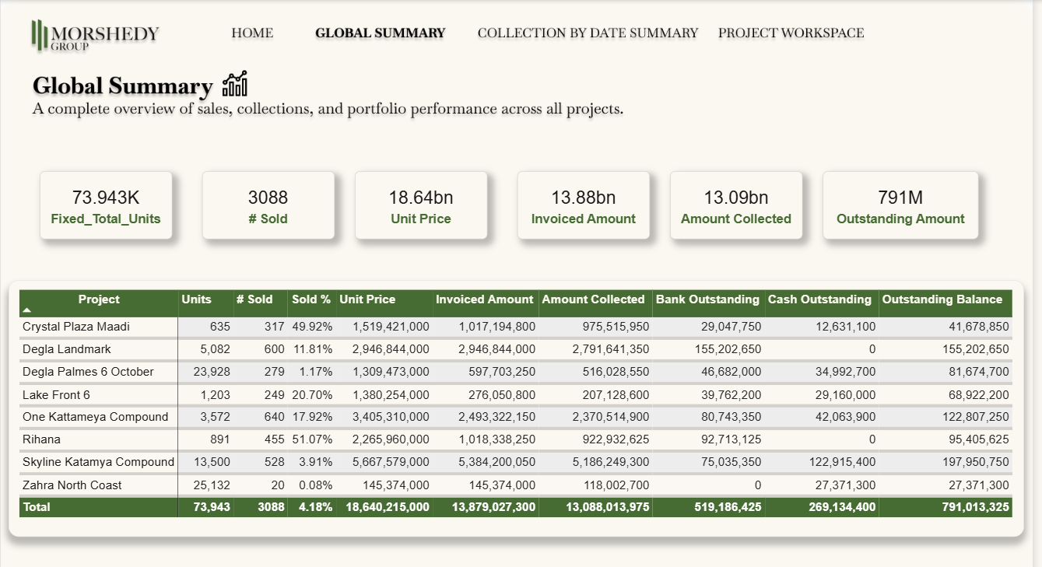
- Collection by date summary

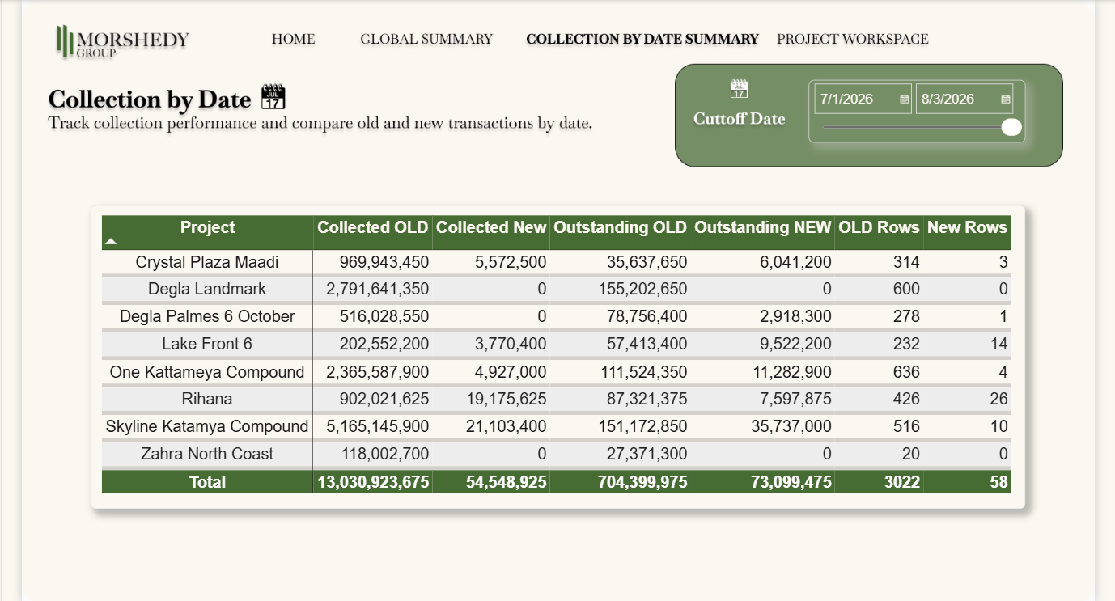

- Project Overall
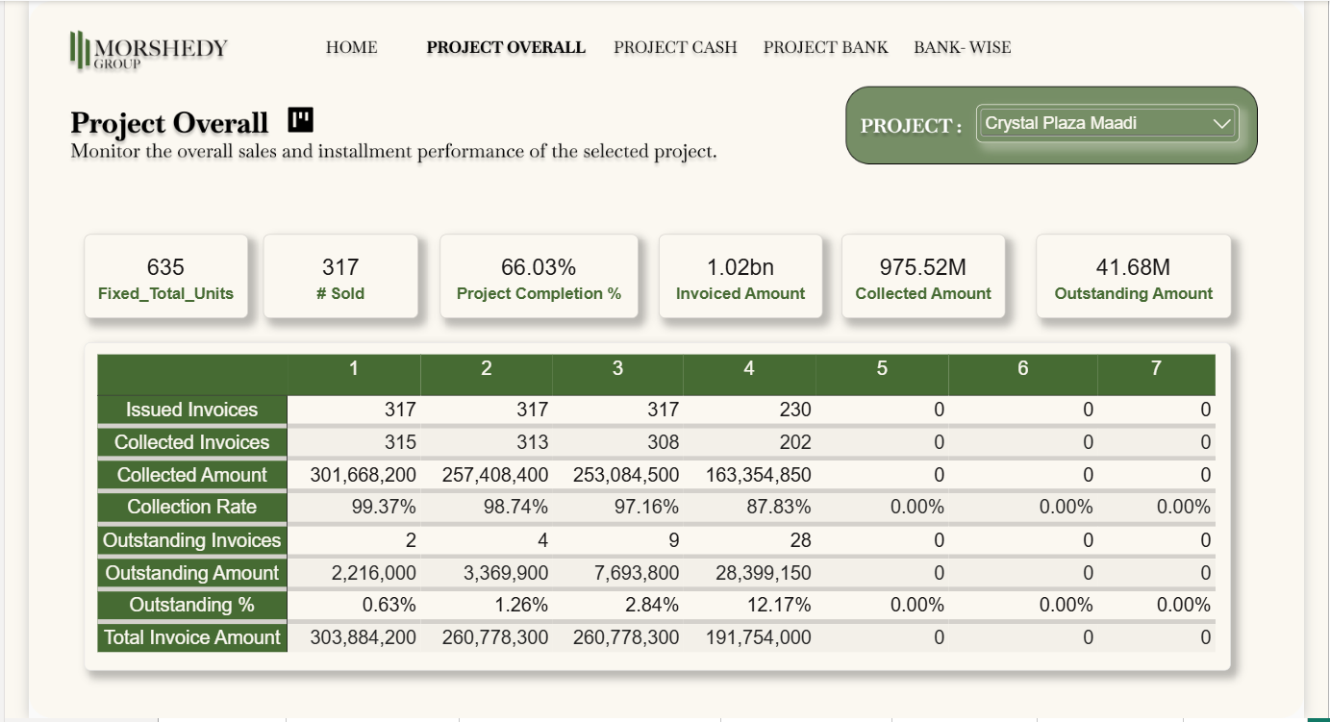

- Project Cash
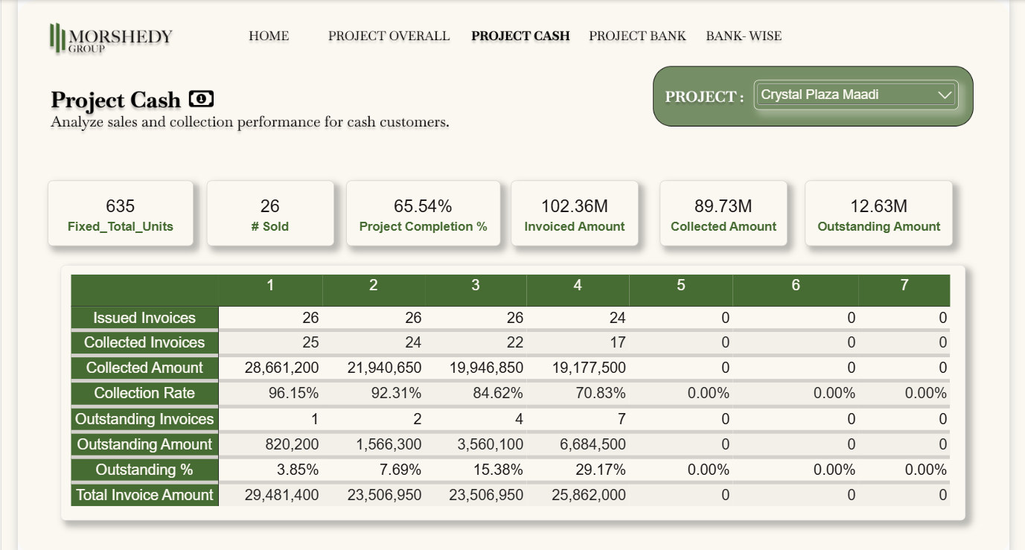

- Project Bank

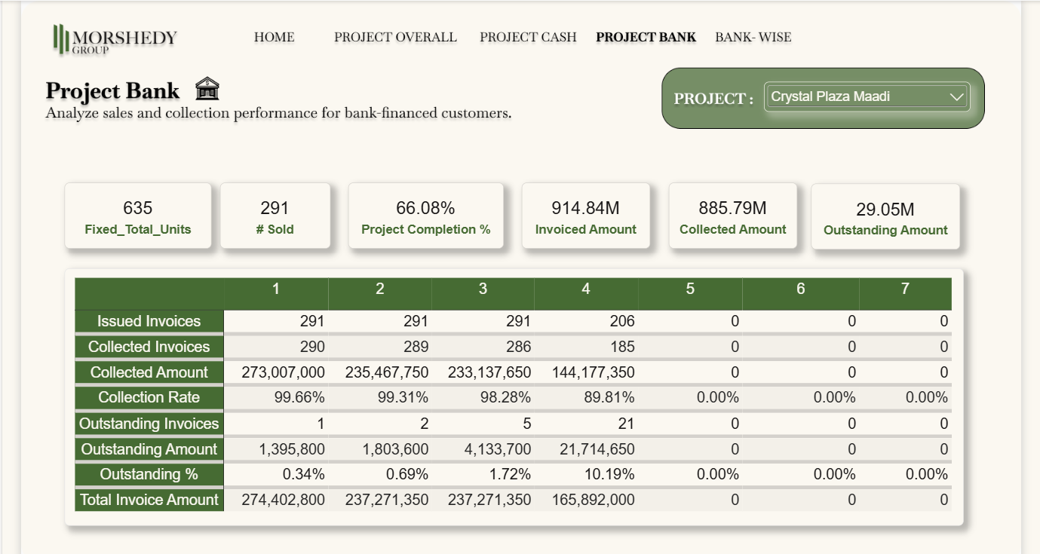

- Bank-Wise

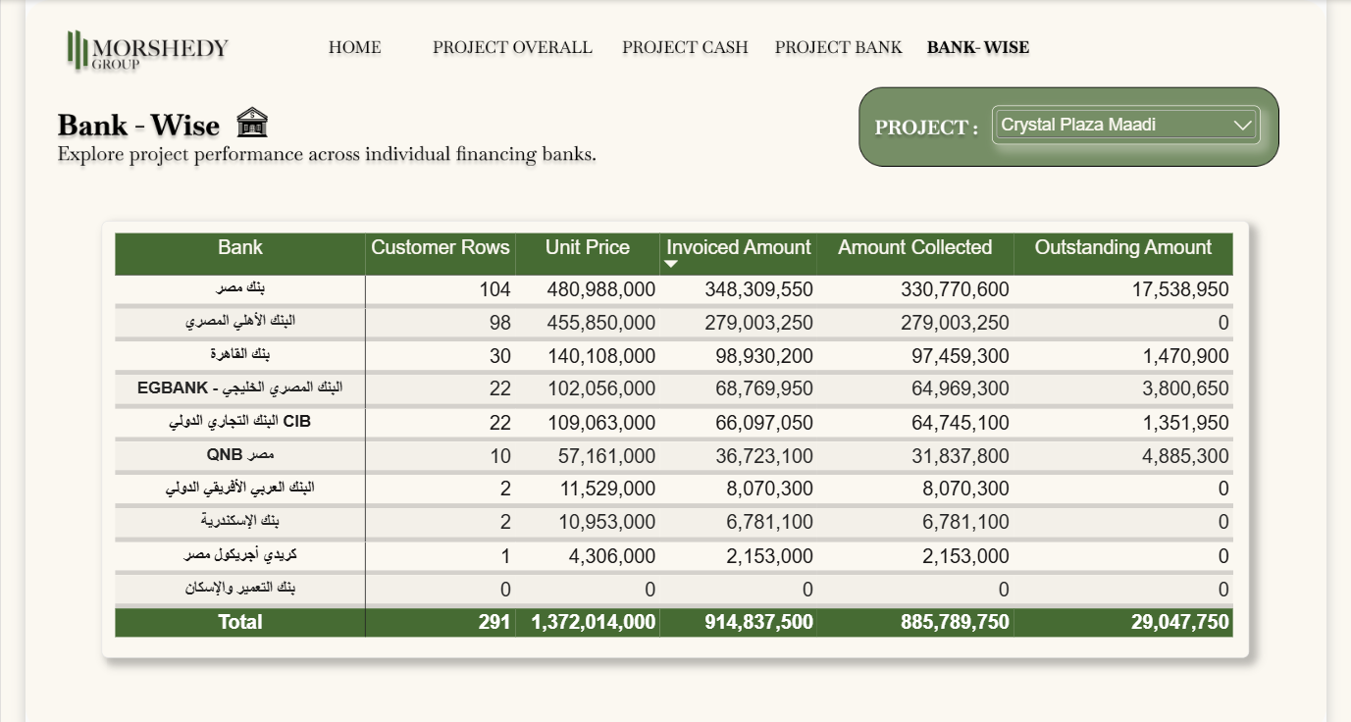

UI/UX Principles
- Consistent page layout across the report.
- Clear KPI cards for important metrics.
- Simple navigation buttons.
- Home button on analytical pages.
- Consistent titles and KPI order.
- Project Completion % and No. of Units displayed on project pages.

Design and Colors

This dashboard is designed using Figma and colors palette is taken from the new logo of MORSHEDY GROUP


Insights and Recommendations
1. Strong Overall Collection Performance
Insight:
Across the 8 projects, 3,088 units were sold with a total sold-unit value of approximately EGP 18.64B. The dashboard shows EGP 13.88B in invoiced amounts, of which EGP 13.09B has been collected. This gives an overall collection rate of approximately 94.3% by amount, while the remaining outstanding balance is about EGP 791.0M.
Recommendation:
Management should maintain the current collection follow-up process while giving special attention to the remaining EGP 791.0M outstanding balance.
Business Value:
This gives management a clear view of the portfolio's overall collection position.

2. Outstanding Balance Is Concentrated in Three Projects
Insight:
The total outstanding balance is approximately EGP 791.0M. Three projects account for about 60.2% of this amount:
- Skyline Katamya Compound: EGP 198.0M
- Degla Landmark: EGP 155.2M
- One Kattameya Compound: EGP 122.8M
Together, these three projects represent approximately EGP 476.0M of the total outstanding balance.
Recommendation:
Management should give these projects closer collection monitoring and review their outstanding installments regularly.
Business Value:
Focusing on the projects with the largest outstanding balances can help management monitor the largest collection exposures.

3. Installment 7 Has the Largest Collection Gap
Insight:
Installment 7 shows a major collection gap. Out of approximately EGP 158.7M issued for this installment, only EGP 3.35M has been collected, leaving around EGP 155.4M outstanding.
The collection rate for Installment 7 is only about 2.1%, compared with much higher rates for the earlier installments.
Recommendation:
The collection team should closely monitor Installment 7 and follow up on unpaid amounts as they become due.
Business Value:
Installment 7 represents the largest installment-level outstanding exposure in the portfolio.

4. Installments 4 and 5 Also Need Collection Monitoring
Insight:
Collection performance decreases in the later installment stages. Installment 4 has a collection rate of about 92.0%, while Installment 5 is about 92.5%. Their outstanding balances are approximately EGP 175.3M and EGP 110.9M, respectively.
Recommendation:
Management should increase follow-up for later installments, especially Installments 4 and 5, before unpaid balances become larger.
Business Value:
The analysis shows that collection attention should not focus only on the first installments.

5. Cash Customers Have a Higher Collection Rate Than Bank Customers
Insight:
Cash customers have approximately EGP 5.14B collected and EGP 269.1M outstanding, giving a collection rate of about 95.0% by amount.
Bank-financed customers have approximately EGP 7.95B collected and EGP 521.9M outstanding, giving a collection rate of about 93.8%.
Recommendation:
Management should continue monitoring Cash and Bank customers separately and give additional attention to the bank-financed portfolio because it contains the larger outstanding balance.
Business Value:
Separating the two payment methods makes collection performance easier to understand.

6. Outstanding Bank Exposure Is Concentrated in Two Banks
Insight:
Within the bank-financed portfolio, Banque Misr has approximately EGP 152.2M outstanding, while National Bank of Egypt has approximately EGP 150.7M outstanding.
Together, these two banks represent around 58.0% of the total bank outstanding balance of EGP 521.9M.
Recommendation:
Management should regularly monitor outstanding balances by bank and strengthen follow-up for the banks with larger outstanding exposure.
Business Value:
Bank-wise analysis helps identify where a large part of the financed outstanding balance is concentrated.

7. Sales Value Is Concentrated in a Few Projects
Insight:
The total sold-unit value across the portfolio is approximately EGP 18.64B. Three projects contribute about 64.5% of this value:
- Skyline Katamya Compound: EGP 5.67B
- One Kattameya Compound: EGP 3.41B
- Degla Landmark: EGP 2.95B
This means that a large part of the portfolio's sales value is concentrated in these projects.
Recommendation:
Management should monitor both sales and collection KPIs for these projects because changes in their performance can have a noticeable effect on the overall portfolio.
Business Value:
This connects sales exposure with collection monitoring instead of looking at sales numbers alone.

8. Collection Performance Differs Significantly Across Projects
Insight:
Collection performance varies across the projects.
For example:
- Skyline Katamya Compound: 96.3%
- Crystal Plaza Maadi Compound: 95.9%
- One Kattameya Compound: 95.1%
- Lake Front 6: 75.0%
- Zahra North Coast: 81.2%
The difference between the highest and lowest collection rates is more than 21 percentage points.
Recommendation:
Management should compare project-level collection rates regularly and investigate the reasons behind lower collection performance in projects such as Lake Front 6 and Zahra North Coast.
Business Value:
A single portfolio-level collection rate can hide significant differences between projects.

9. Project Completion Does Not Always Match Collection Progress
Insight:
Project completion and financial collection do not always move at the same level.
For example:
- Zahra North Coast has 100% POC, but its collection rate is approximately 81.2%.
- Rihana has approximately 91.6% POC and 90.6% collection.
- Lake Front 6 has approximately 6.9% POC, but its collection rate is already around 75.0%.
This shows that engineering/project completion and payment collection are different performance indicators.
Recommendation:
Management should monitor Project Completion % and Collection Rate together, rather than using project completion as an indicator of collection performance.
Business Value:
This provides a more complete view of both operational progress and financial performance.

10. A Large Amount of Future Value Is Not Yet Due
Insight:
The sold-unit value is approximately EGP 18.64B, while approximately EGP 13.88B has already become invoiced under the current installment status. This leaves approximately EGP 4.76B of sold-unit value that is not yet included in the current invoiced amount.
This is different from the EGP 791.0M outstanding balance, because outstanding amounts are already due but not collected, while the remaining value is related to future installments.
Recommendation:
Management should clearly separate Outstanding Amount from Future Not-Due Amount when planning cash flow and collection activities.
Business Value:
This prevents future scheduled payments from being treated as overdue amounts and gives a clearer view of expected future collections.

